A000-ME-Bactria-Margina-Seated female figure-Chlorite and Calcite-Falling Leaves Cloak-2000-1650 BCE

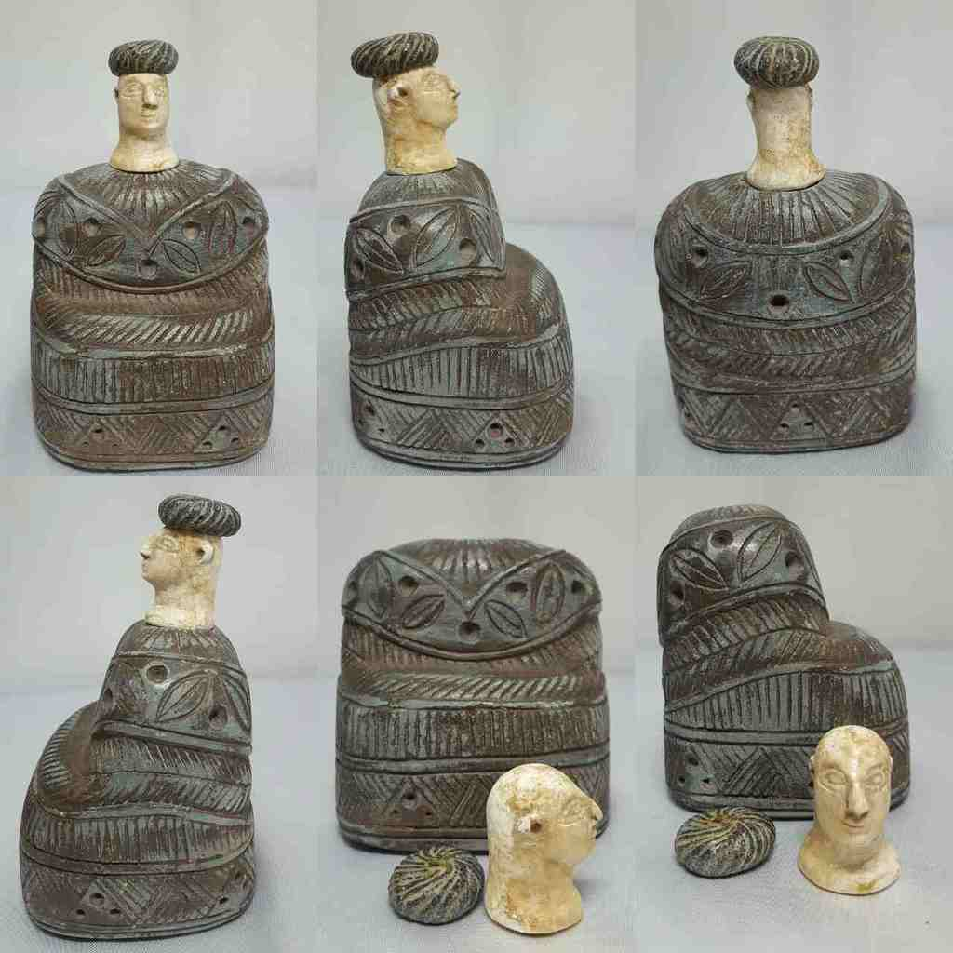

Figs. 1-6. Bactria-Margina-Seated female figure-Chlorite and Calcite-Falling Leaves Cloak-2000-1650 BCE

Formal Label: Bactria-Margina-Seated female figure-Chlorite and Calcite-Falling Leaves Cloak-2000-1650 BCE

Case No.: 3

Accession Number: GN778.32.A3

Date or Time Horizon: Middle to Late Bronze Age, 2000-1650 BCE

Geographical Area: Afghanistan

Cultural Affiliation: BMAC (Oxus)

Formal Label: Bactria-Margina-Seated female figure-Chlorite and Calcite-Falling Leaves Cloak-2000-1650 BCE

**Display Discussion**: This type of statuette, which can be separated into green chlorite for the base and hat and white alabaster or marble for the head, originated with the Oxus civilization now known as the Bactria-Margiana Archaeological Complex of Central Asia (Bactria, to the east, and Margiana, to the west). Its sites were discovered and named by the Russian archaeologist Viktor Sarianidi (1976). Sarianidi's excavations revealed numerous monumental structures fortified by walls and gates.

LC Number: GN778.32.A4

Display Description:

Date or Time Horizon: Middle to Late Bronze Age, 2000-1650 BCE

Geographical Area: Afghanistan

GPS:

Map:

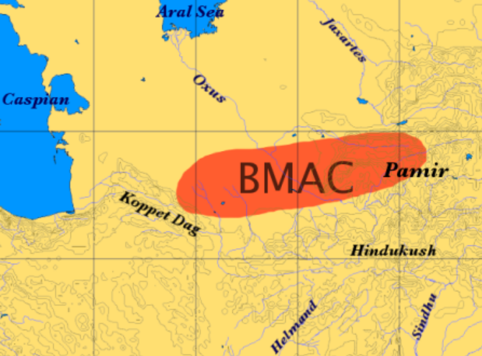

Fig. 7. Map of the extent of BMAC after https://upload.wikimedia.org/wikipedia/commons/a/aa/BMAC.png

Cultural Affiliation: BMAC, Bactria Margiana Archaeological Culture (Oxus Culture)

Media: composite chlorite body and cap and white calcite head

Dimensions: H 14 cm x W 10 cm

Weight:

Provenance: [vintage.intaglio](http://myworld.ebay.com/vintage.intaglio), Thailand

**Discussion:**

The biggest volume of the statuette is occupied by a very large dress with puffed sleeves, covered from the waist by a gown which accentuates its amplitude; The two parts of the garment are of a woolly material stylized in superposed tabs, which is obviously inspired by the Sumerian kaunakes, skirt with long hair arranged in scales. A rigid headgear with a tip at the back encloses all the hair and makes it difficult to distinguish between the two.

The manufacture obeys very precise canons: head and costume are carved in a gray steatite, while the lightest stone serves uncovered parts of the body; The module corresponding to the face and neck extended by a décolleté begins to fit exactly into the neckline of the garment. The "princesses of Bactria" eventually represented ladies of the aristocracy, perhaps even deified, but most often they personified was the “mother goddess” who, in the mythology of Central Asia, plays a regulatory role in the order of nature, pacifying the wild forces incarnated by lions, serpents or dragons. It is very identifiable in the glyptic, its identity is more controversial in the statuary.

**References:**

Bryant, Edwin. 2001) [The Quest for the Origins of Vedic Culture](https://en.wikipedia.org/wiki/The_Quest_for_the_Origins_of_Vedic_Culture): The Indo-Aryan Migration Debate. Oxford University Press.

CNRS. 1985. L'archéologie de la Bactriane ancienne, actes du colloque franco-soviétique n° 20. Paris: Editions du Centre National de la Recherche Scientifique, 1985,

Forizs, L. 2016, 2003. [Apāṁ Napāt, Dīrghatamas and Construction of the Brick Altar. Analysis of RV 1.143](https://www.academia.edu/4277610/Apāṁ_Napāt_Dīrghatamas_and_Construction_of_the_Brick_Altar._Analysis_of_RV_1.143) 

Fussman, G.; et al. 2005. Aryas, Aryens et Iraniens en Asie Centrale. Paris: de Boccard.

Lubotsky, A. 2001. ["Indo-Iranian substratum"](https://web.archive.org/web/20080411120201/http:/www.ieed.nl/lubotsky/pdf/Indo-Iranian substratum.pdf) (PDF). In Carpelan, Christian. Early Contacts between Uralic and Indo-European. Helsinki: Suomalais-Ugrilainen Seura.

Sarianidi, V. I. 1994. "Preface". In Hiebert, F. T. Origins of the Bronze Age Oasis Civilization of Central Asia. Cambridge: Harvard University Press.

Sarianidi, V. I. 1995. "Soviet Excavations in Bactria: The Bronze Age". In Ligabue, G.; Salvatori, S. Bactria: An ancient oasis civilization from the sands of Afghanistan. Venice: Erizzo.  .

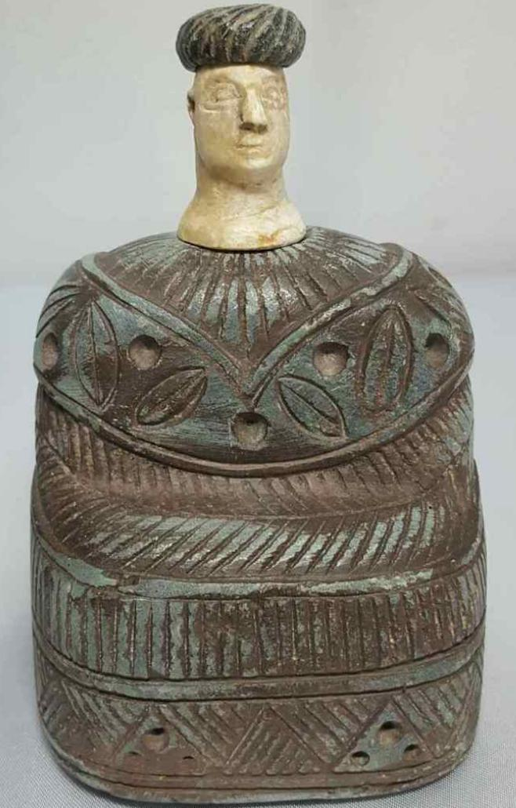

Sold by [vintage.intaglio](http://myworld.ebay.com/vintage.intaglio) ( [457](http://feedback.ebay.com/ws/eBayISAPI.dll?ViewFeedback&userid=vintage.intaglio) )

Estimated delivery Tuesday, Dec 27, 2016 - Wednesday, Jan 11, 2017

#### [Old Bactrian composite stone seated female figure idol Statue # M](http://www.ebay.com/itm/282284524718)

|  |  |
| --- | --- |
| Item price | $560.00 |
| Quantity | 1 |
| Item number | 282284524718 |
| Shipping service | Economy Shipping from outside US |

## Shipping address

Ralph J Coffman Jr

149 Atlantic Ave

Swampscott MA 01907-2427

United States

## Order total

|  |  |
| --- | --- |
| Subtotal | $560.00 |
| Shipping | $5.00 |

**Total**

$565.00